◬The Triangular Paradox◬
[Conceptualized by ‘PurpsTheGuy’ on TikTok]

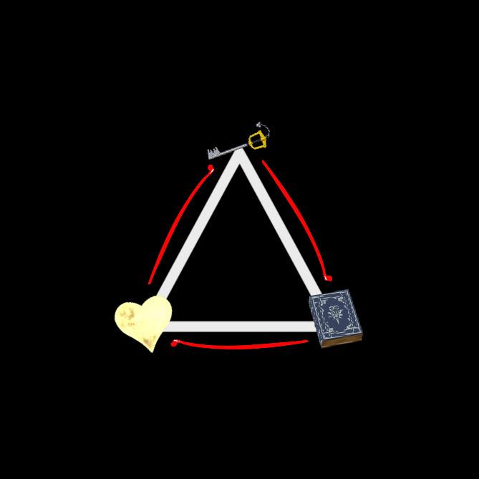

- The “True” Kingdom Hearts (A):

According to the ancient Keyblade War legend, the original and true Kingdom Hearts was completely consumed by Darkness. The worlds before were all connected by one sky, but the violent clash of light and darkness caused the worlds to break apart. As Kingdom Hearts was completely swallowed by the darkness, it shed off a piece of its essence and it is casted forward through time. This fragmented piece of Kingdom Hearts's essence drifted for eons through the cosmos in search for a completely new, “blank slate” to latch itself onto so it can survive.
Within the lore of KH, when a heart succumbs to darkness the “heart” is forcibly disconnected from its physical vessel, leaving behind an empty husk (which can later manifest into a Nobody). The heart itself manifests as a creature of darkness known as ‘Heartless', which is driven by the instinct to consume other hearts and spread darkness.
If Kingdom Hearts is an entity of pure light and the supreme, godlike metaphysical core of the universe, it could likely operate on different physics than what normal mortals experience when losing their hearts to darkness. Kingdom Hearts is the pure source of light, so if it is eclipsed in darkness it would need to transform itself to survive.

- Sora "The Ordinary Boy" (B):
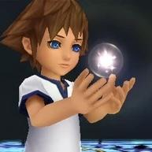
The fragment eventually drifts into an isolated world known to us as "Destiny Islands' where it locates a newborn vessel. This vessel is an infant baby Sora. The reasoning as to why this fragment chooses Sora's vessel and not an engineered-vessel or an adult-vessel is because of the fact that, the engineered vessels that are created by Vexen are too fragile and incomplete, and adult-vessels have unhealed trauma, memories, and a strong will. The result of this connection is the reason as to why Ventus was drawn in by Sora's heart, this allowed Sora to mend Ventus's heart in the process as an infant. At the beginning of Birth By Sleep, Ventus's heart was fractured and dying, but it was the pure light from infant baby Sora that connected with him, which allowed Ventus to heal.

- “The Singularity” (C):
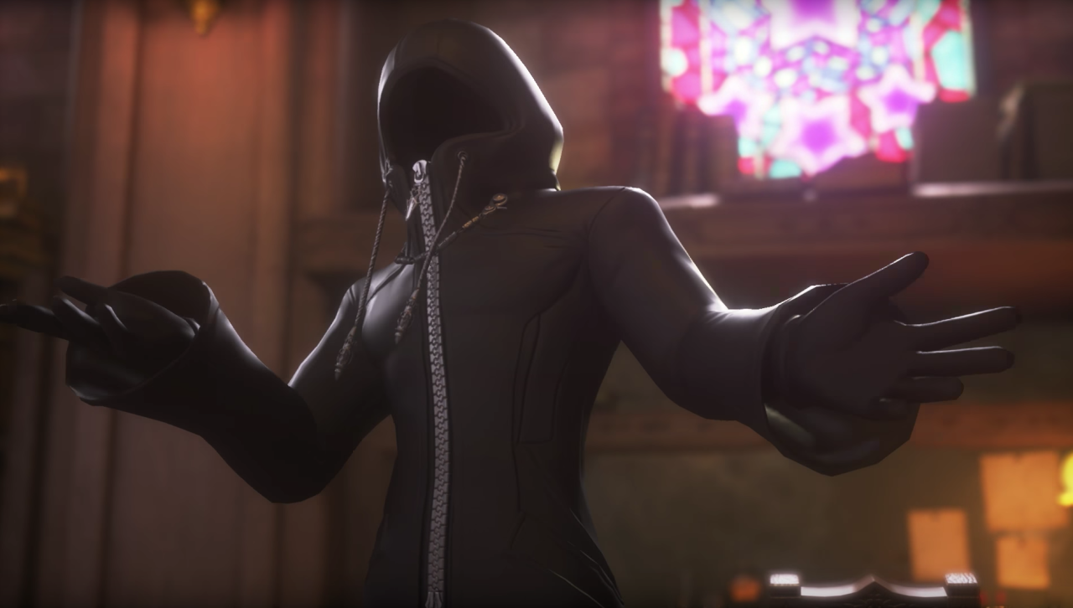
Soras's inability to realize his true nature, lies in the fact that, during the clash of the Ancient Keyblade War when the worlds that once coexisted under the same sky broke apart, the fragment that was tossed forward in time suffered extreme consequences afterwards. As a result of these events, the fragment suffered from Cosmic Amnesia (a spiritual wall blocking someone from understanding their spiritual or cosmic nature).
This is what keeps Sora from understanding what his true nature and origins are. Because of this, Sora's capabilities and full power are unknown to him. This incredible amount of unguided power eventually causes the timeline to bend at Sora's will after he abuses the power of waking a total of 7 times. The bending of time causes a “singularity” in the timeline (the Master of Masters), this singularity is tossed backwards into the ancient past during the time the worlds were all scattered. This singularity is Kingdom Hearts + Sora amplified to an extreme degree (Explaining why the Master of Masters is so infatuated with light and his desire for the universe to be totally bathed in light, completely eliminating the darkness once and for all).
———————————————————————
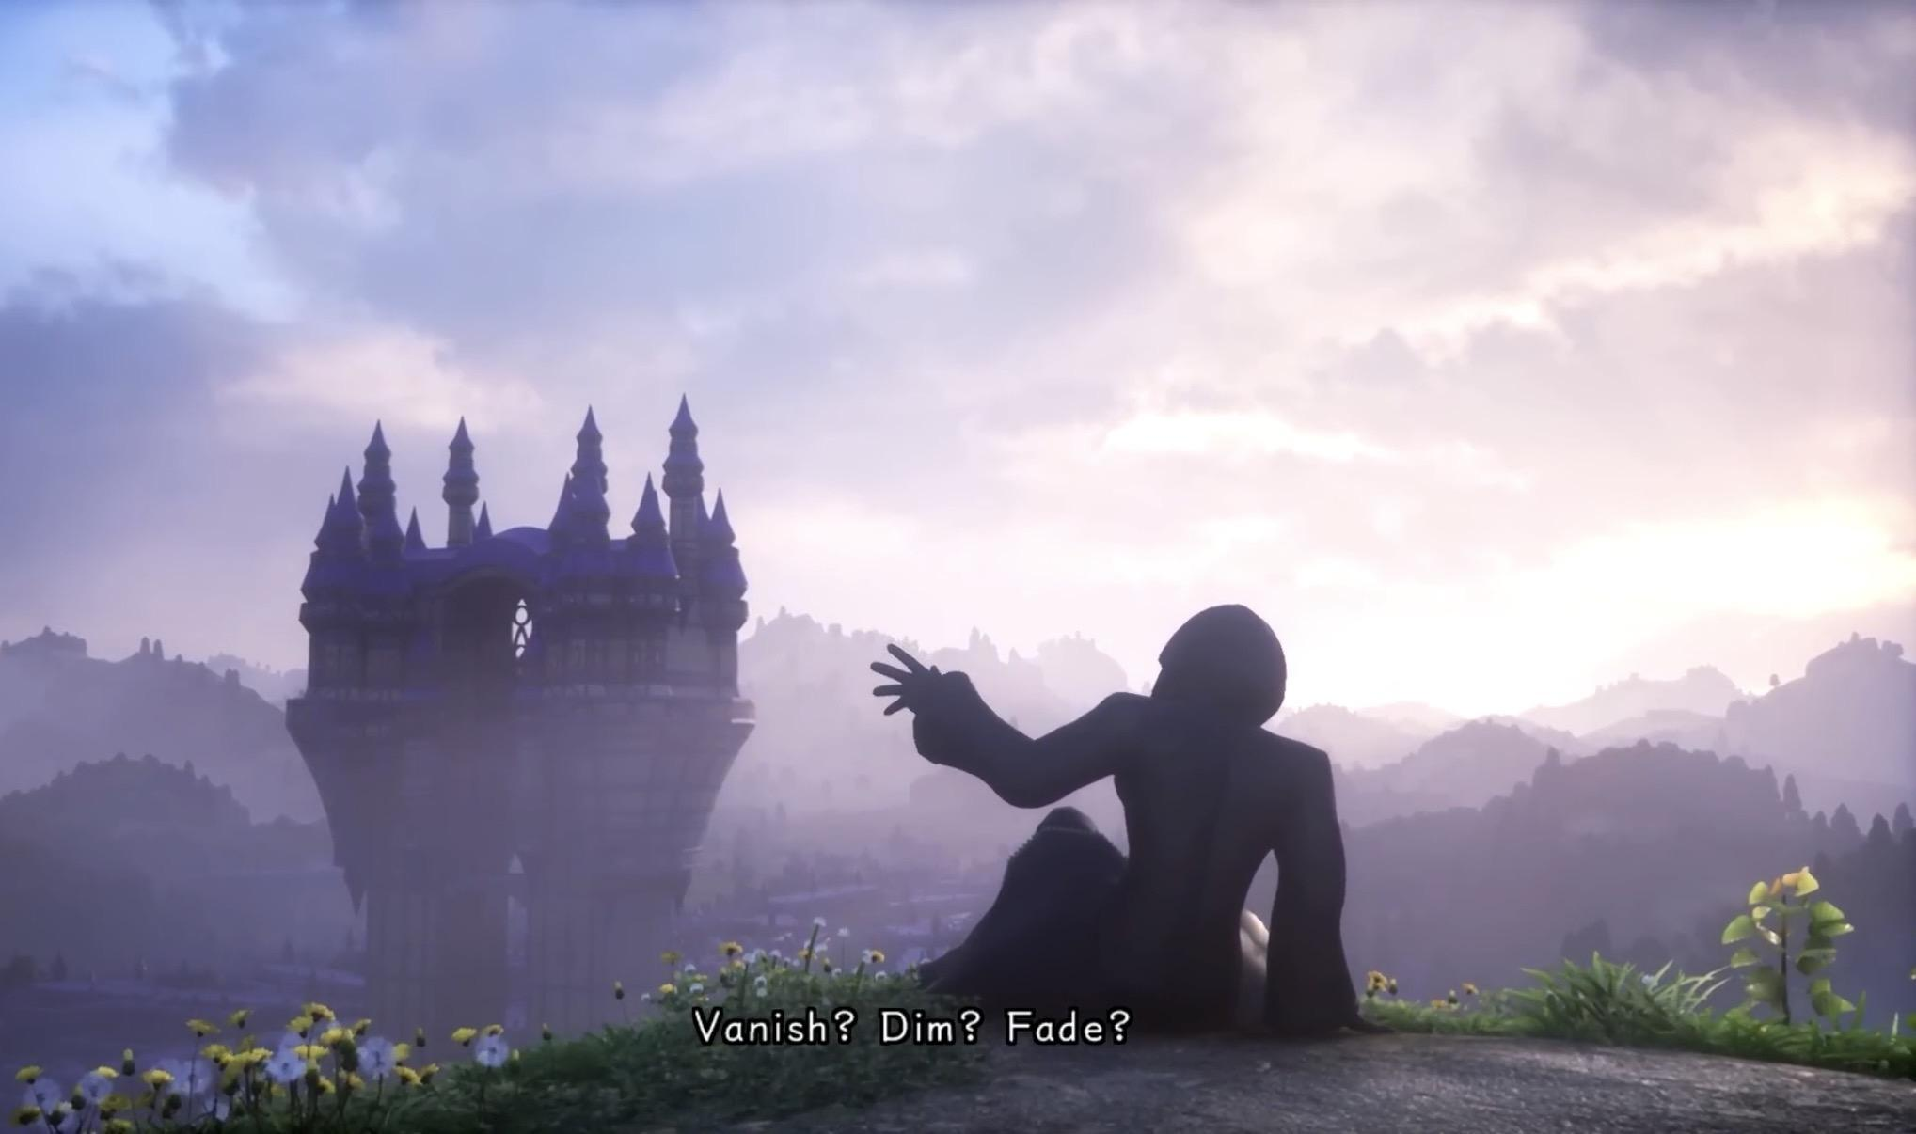
- Who is the Master of Masters?
Quote from ‘Tetsuya Nomura’
"The power of waking is essentially 'the power to put sleeping hearts back the way they were, but the impact of forcing his friends’ fading hearts back the way they were rewrote reality, and created a singularity. The rewrite caused the chronology in which they were destroyed to have ‘never happened.’”
A singularity within science, mathematics, and technology, is a "point" where normal rules, equations, or physical laws completely break down.
Let’s take a black hole for example:
- Classic physics states that when a massive star collapses, its entire mass is compressed into a geometric point of zero volume and infinite density. This point sits at the absolute center of a black hole.
Hypothetically speaking, the Master of Masters could be this compressed star, that metaphorically becomes a black hole that sucks in all information. This explains how the Master is capable of knowing the events in the timeline. By being tossed through time, this singularity—aka the Master—effectively absorbed all the information that was around him during the events of his birth.
The Master uses those around him as though they are like chess pieces on a cosmic chessboard. This should be an indication to everyone that this character should not be trusted. He deliberately carries a goofy persona, acts quirky, and uses over the edge jokes to make people drop their guard. He carries this personality deliberately in order to hide his true intentions.
In physics, ‘Hawking Radiation’ is a term explaining the theoretical thermal radiation emitted by black holes, due to quantum effects near the “event horizon”, causing the black hole to slowly lose mass and "evaporate" over time. These black holes slowly leak out a tiny bit of heat and information over-time.
As I have already established, the consequences of Sora's unguided abuse of power caused a singularity within the timeline which could have metaphorically created a "black hole" , with The Master of Masters being the absolute center of this compressed energy. If Hawking Radiation plays a role in this, then that could mean that The Master of Masters’ true memories and identity are slowly leaking out.
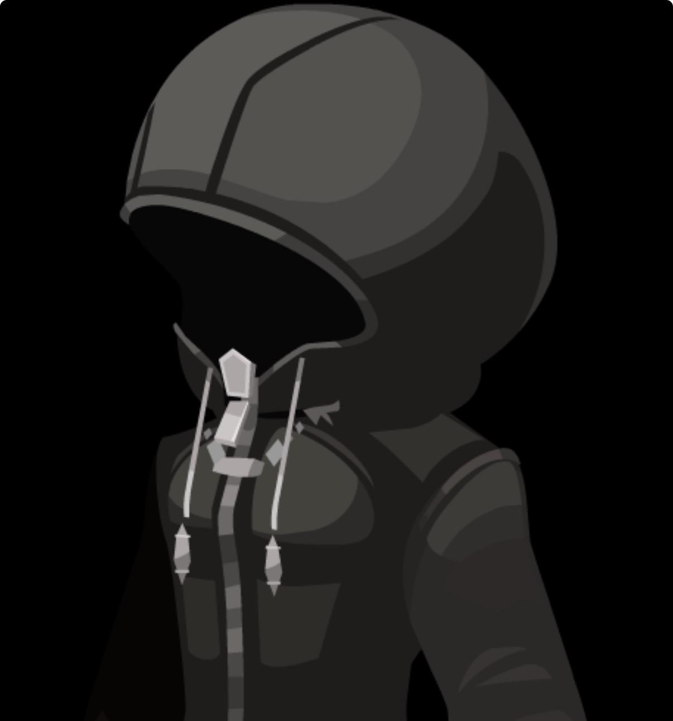
In theoretical science, and black hole thermodynamics, the holographic principle suggests that the ‘event horizon' of a black hole is what keeps all information stored at its core, meaning the event horizon essentially acts as the boundary of stored information.
The coat that the Master of Masters’ wears could be a metaphorical event horizon that keeps all the information regarding his plan, his identity, and his name completely locked away.
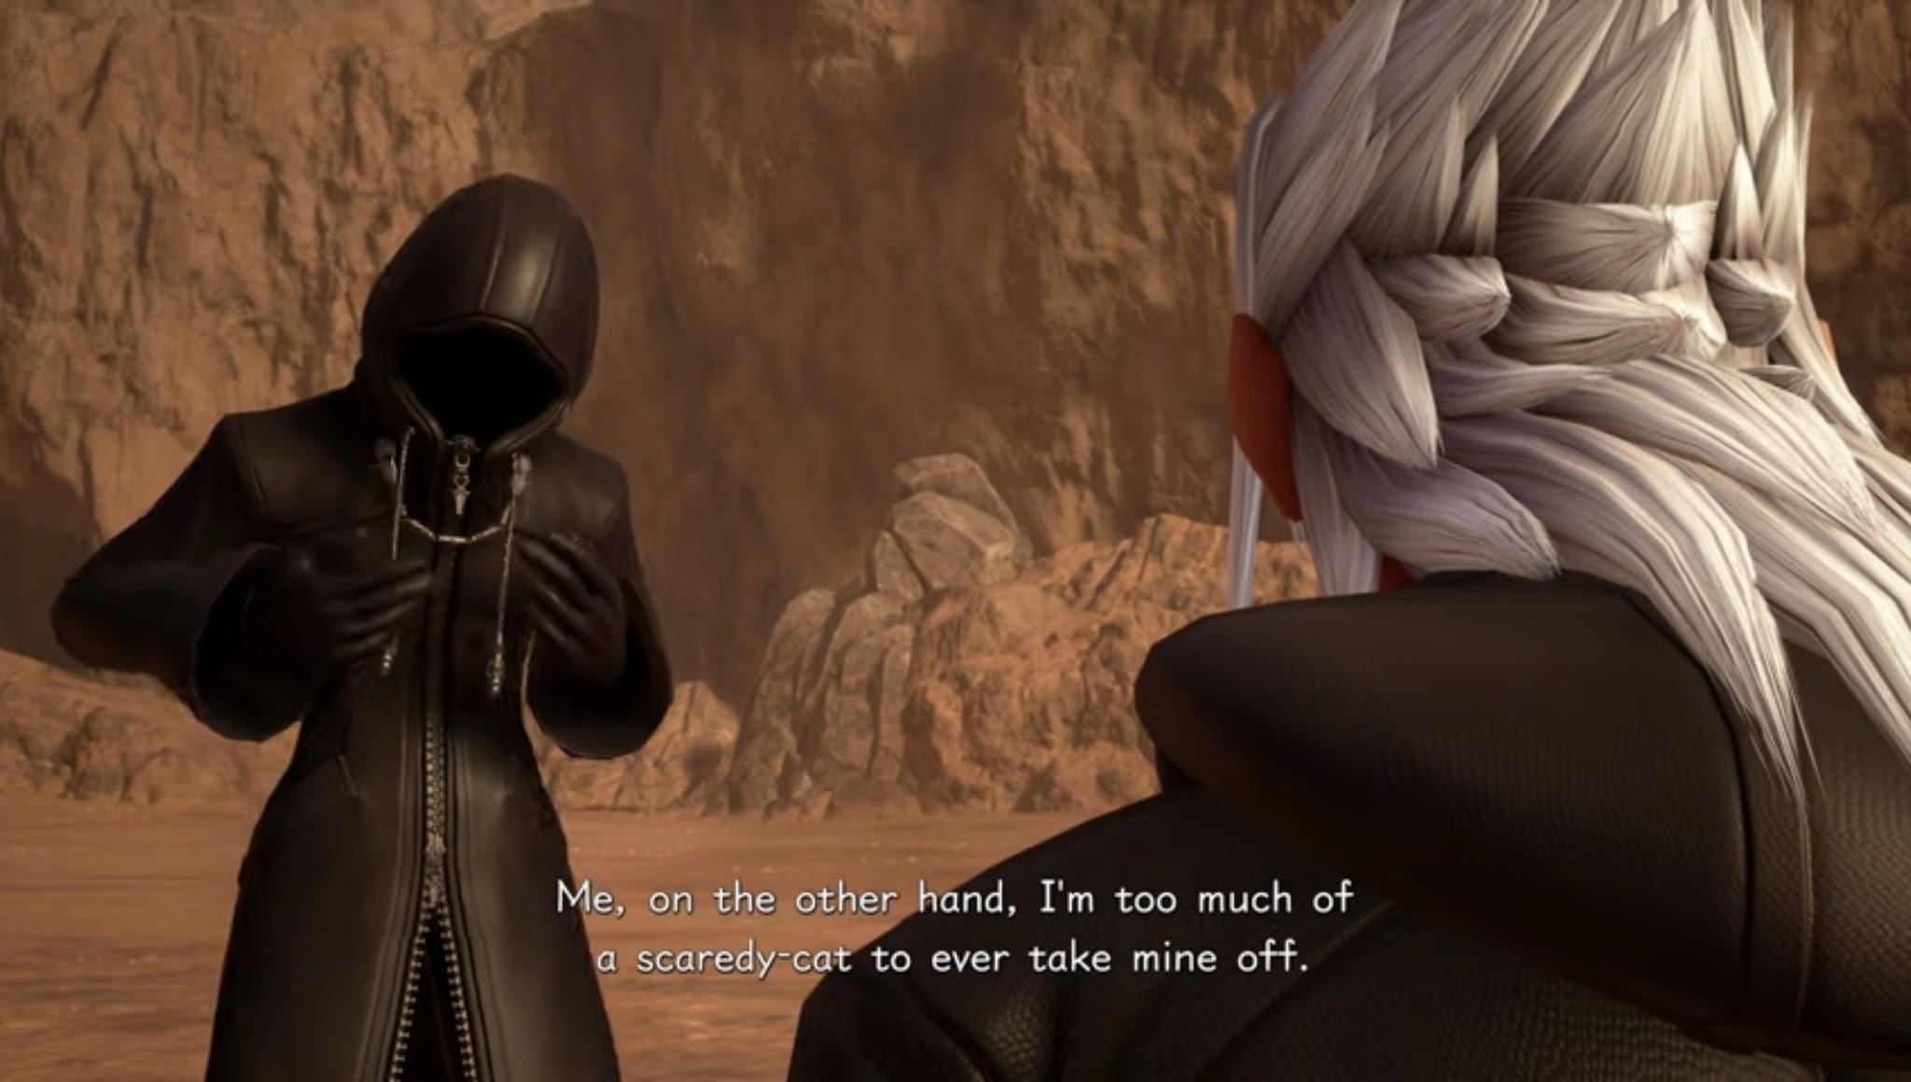
Due to our recent establishment of "Hawking Radiation” the energy within a black hole slowly creeps out which explains The Master of Masters theatrical, highly playful, but mischievous personality that hides his true intentions. The coat acts as the energy’s boundary, keeping everything within the coat stabilized.
——————————————————————
- The Master Plan:

- Luxu’s Role [The Dog on a Leash]
The Master of Masters' plan involves trapping Sora's heart the moment he abuses the power of waking and begins fading from existence. The process of Sora's erasure is not immediate but he abuses the POW a total of 6 times after he and his friends were consumed by the Demon Tide. After Kairi dies to Xehanort, Sora abuses the POW a 7th time which effectively causes his being to slowly fade from the timeline.

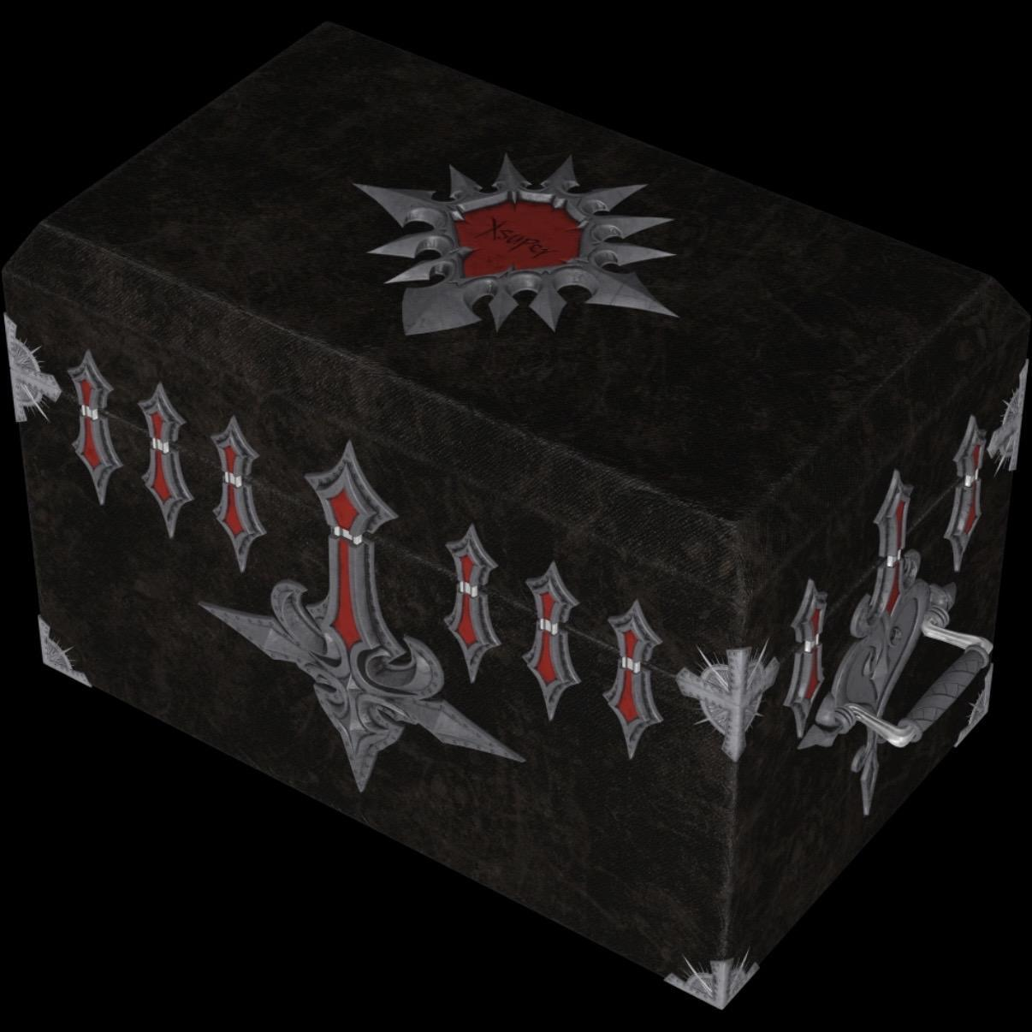
‘The Black Box' that was constructed by the Master is a container for Sora's reconstructed or original heart before he was completely erased from the timeline.
You see... The Master of Masters explicitly gave Luxu crucial roles that included:
- Protecting the “Black Box” and ensuring it reaches its designated location.
- Passing the “No Name” keyblade through history.
- Shedding his old forms and finding new hosts in order to survive through thousands of years.
But, what Luxu doesn’t know yet, is what actually lies within the box. He likely has a vague, or obscure idea, of what lies within the box.
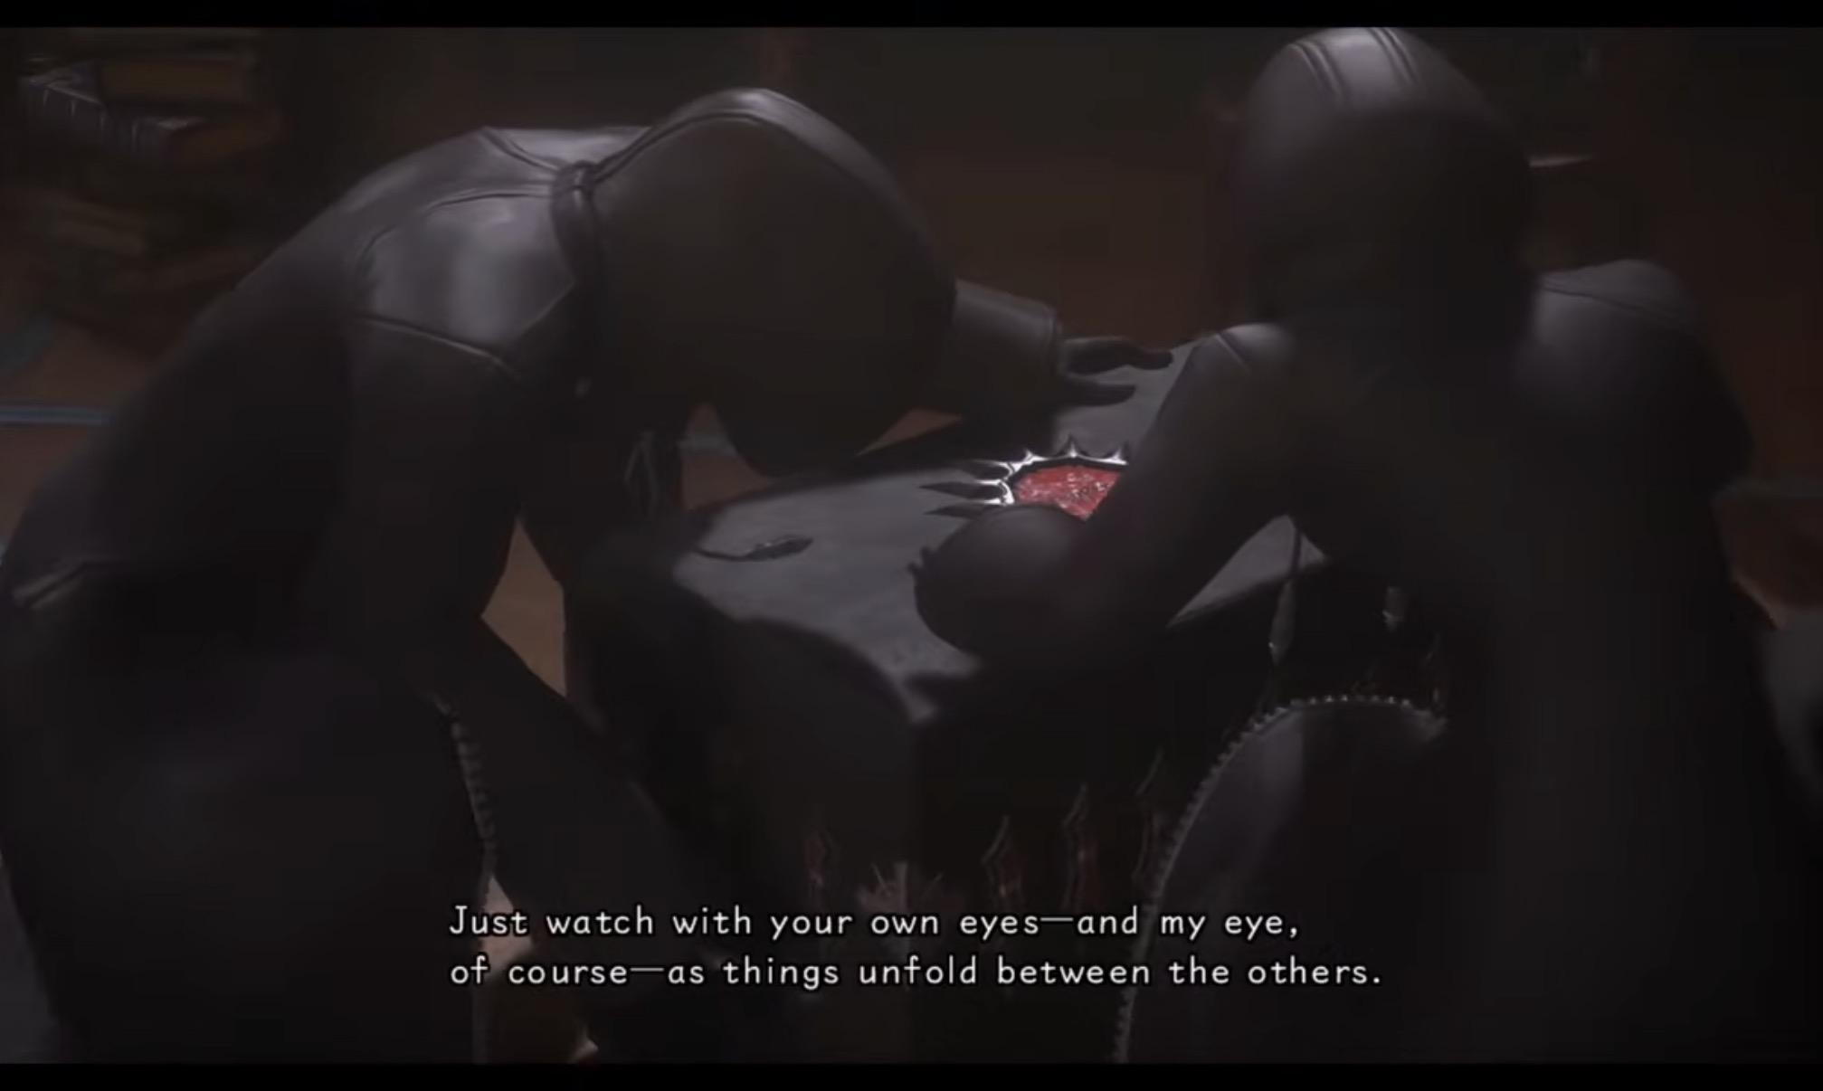
At the end of KH x Back Cover, we see the Master speaking to Luxu about passing down the “No Name” Keyblade and fulfilling his role. After this the Master tells Luxu that him, the Keyblade, and the box must stay “out of sight”.
He explains to Luxu that he must essentially watch and observe the timeline unfold, while insisting he keeps his “Gazing Eye” close at all times. By forcing the thought of, “The Masters’ Keyblade sees the future.”, into Luxu’s mind repeatedly, Luxu becomes “trained” by the Master and is put on a leash.
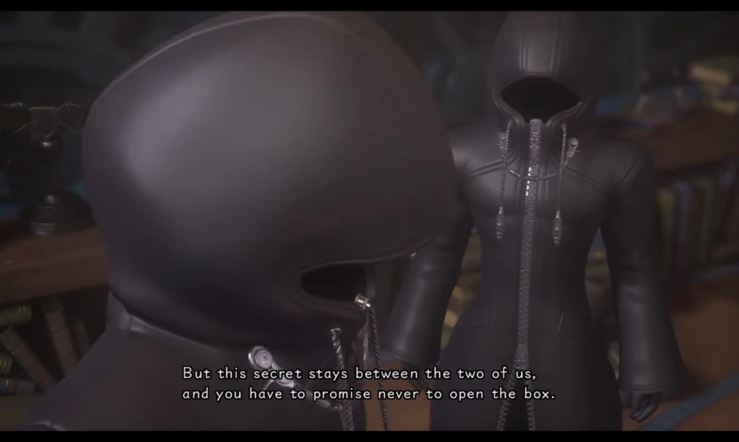
The Master tells Luxu that he will indulge him with the contents of the box, but as we have already established, the Master of Masters is a deliberate liar, mischievous, and extremely manipulative to the point he uses those around him as though they are like chess pieces on a cosmic scale. It is safe to assume that whatever he tells Luxu is either a fabricated lie, or some sort of subversion to keep Luxu from opening the box. Because the Master told Luxu that the secret stays between the two of them, Luxu has no reason to believe he will lie.
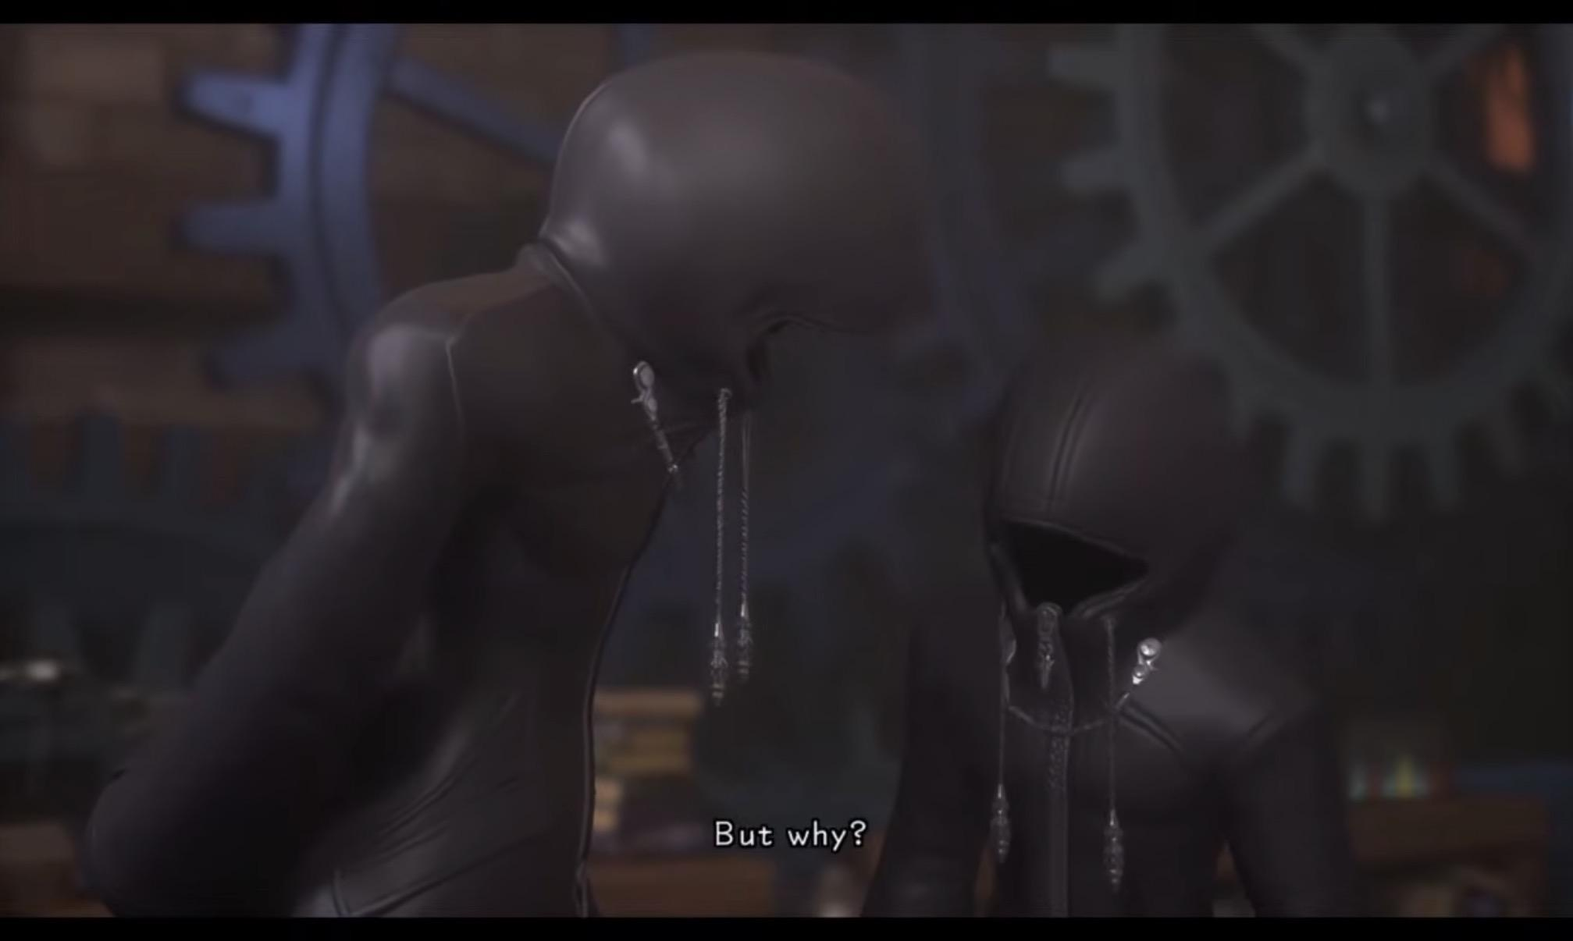
Even though Luxu questions what the Master tells him (seen above), Luxu ultimately falls in line and carries out the Masters’ wish without ever truly rebelling. This highlights the Masters’ absolute psychological impact, and control over everyone around him—turning even his most trusted apprentice into a lifelong pawn on a very tight cosmic leash.

- Sora’s “Unguided” Power [The Trap]
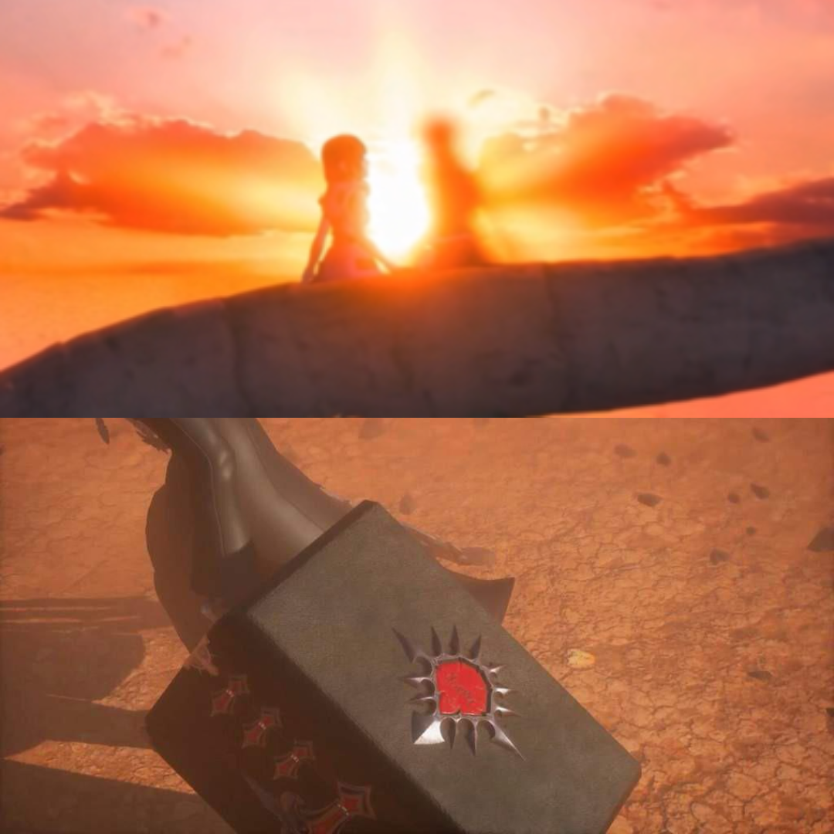
By trapping Sora's heart within the black box, the Master successfully maintains control over the very anomaly that birthed his own existence.
Sora's unguided use of the power of waking doesn't just bend time once—his ability to cause singularities means he is an unpredictable variable who can break the rules and laws of reality.
The Master contains this unchecked source of power locked away tightly inside of the Black Box and Sora drifts into an unfamiliar Final World where he meets Yozora, but Yozora is occupying a vessel that was implanted into “The Realm of Unreality" by The Master of Masters.
- The Vessel Program [Missing Link]
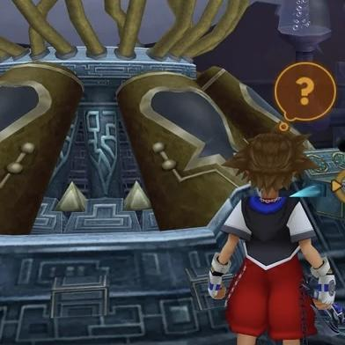
At the end of KH1 all the way back in 2002, Sora actually progresses through what's known as "The End Of The World" or The Final World of the original game. After fighting waves of ‘Heartless’, Sora gets transported to an unfamiliar mysterious room. This particular room—at the time—was left completely unnamed and unexplained for nearly 2 decades.
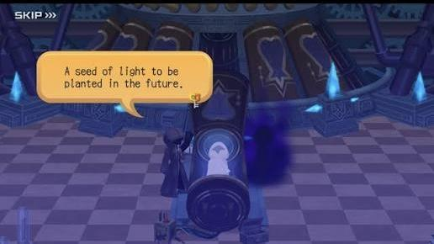
Fast forward to when Union X (Cross) was released we see this room again but with more information about who this room belongs to. It belongs to the Master of Masters, and the machine was designed to be an "Ark" or a "Lifeboat" and it sat in the basement of the Daybreak Town Clock Tower.
The Master used this machine to transport vessels through time and across worlds. The machine can also bridge the gap between reality (The Realm of Light and Darkness), and Un-Reality (Quadratum).
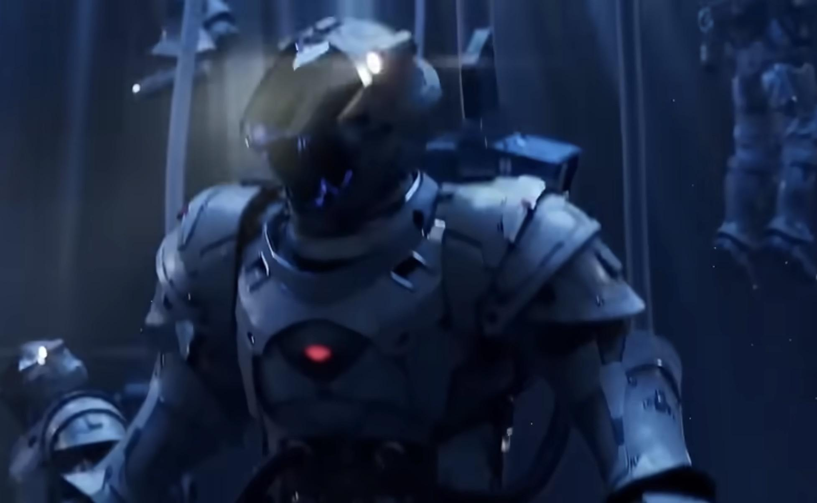
In “KH Missing Link” we see keyblade wielders in futuristic looking suits, diving into another world. The inhabitants of Scala ad Caelum likely uncovered or rediscovered this machine after Daybreak Town was destroyed and Scala ad Caelum was built on top of it, and gave it a new purpose.
This gives an explanation as to what the futuristic suits are, and what the unexplained territory seen in Missing Link is being accessed from. They could be researching this machine, and that explains why these Keyblade wielders that are seen diving are wearing this sci-fi looking armor.
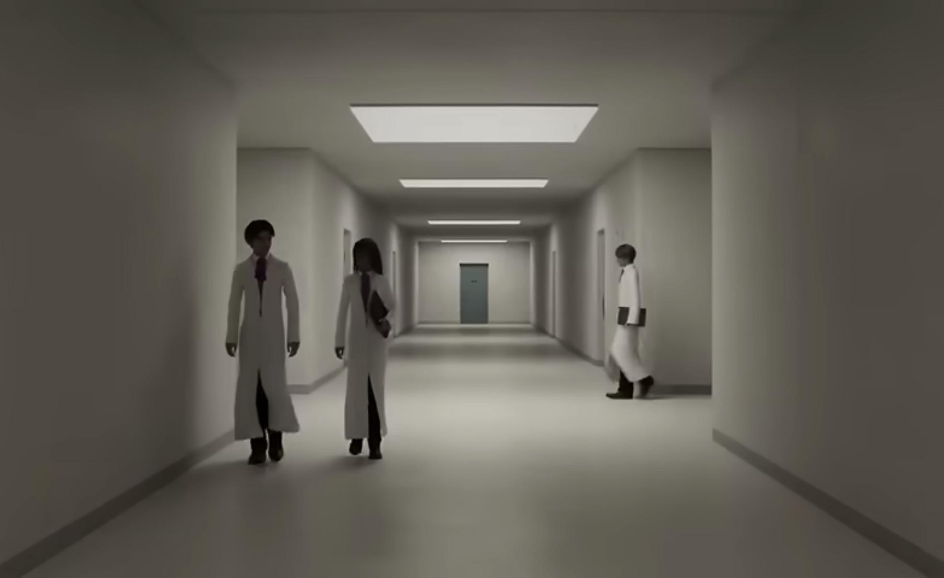
We see what looks to be researchers scrambling and walking through hallways in an unknown lab setting (seen above). That could be the newly established halls leading to the Master of Masters machine in which these “scientists” are studying.
The actual reasoning as to why the Master of Masters built this machine is because during his time in the age of fairytales, he was actively working on a vessel-program that he says is to enable vessels to be transported across time and different worlds. This fundamentally functioned as the primitive predecessor of the Gummi Ship.

- Yozora [Proxy-Vessel]
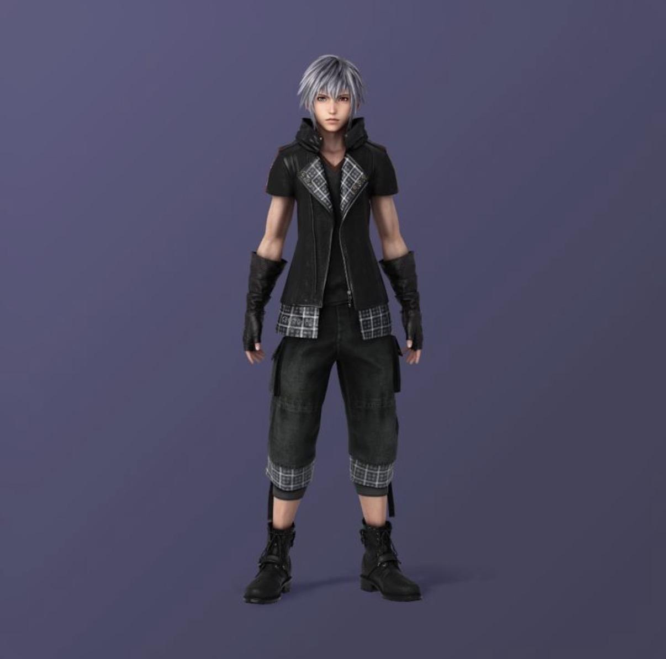
Before actually being able to escape to Quadratum, the Master required an anchor inside The Realm of Reality. By using this machine, and the accumulated knowledge he gained from the vessel-program, the Master creates a high-level “proxy” and transports this “proxy-vessel” into the The Realm of Unreality.
This “Proxy-Vessel” is who we encounter within the unfamiliar Final World seen in the secret epilogue of KH 3. This Final World is representative of Yozora. The Sky within this Final World is during the night, while Sora’s final world is during the day. This juxtaposition suggests that the domain Sora drifts into after his being is completely erased from existence, is actually Yozora’s domain.
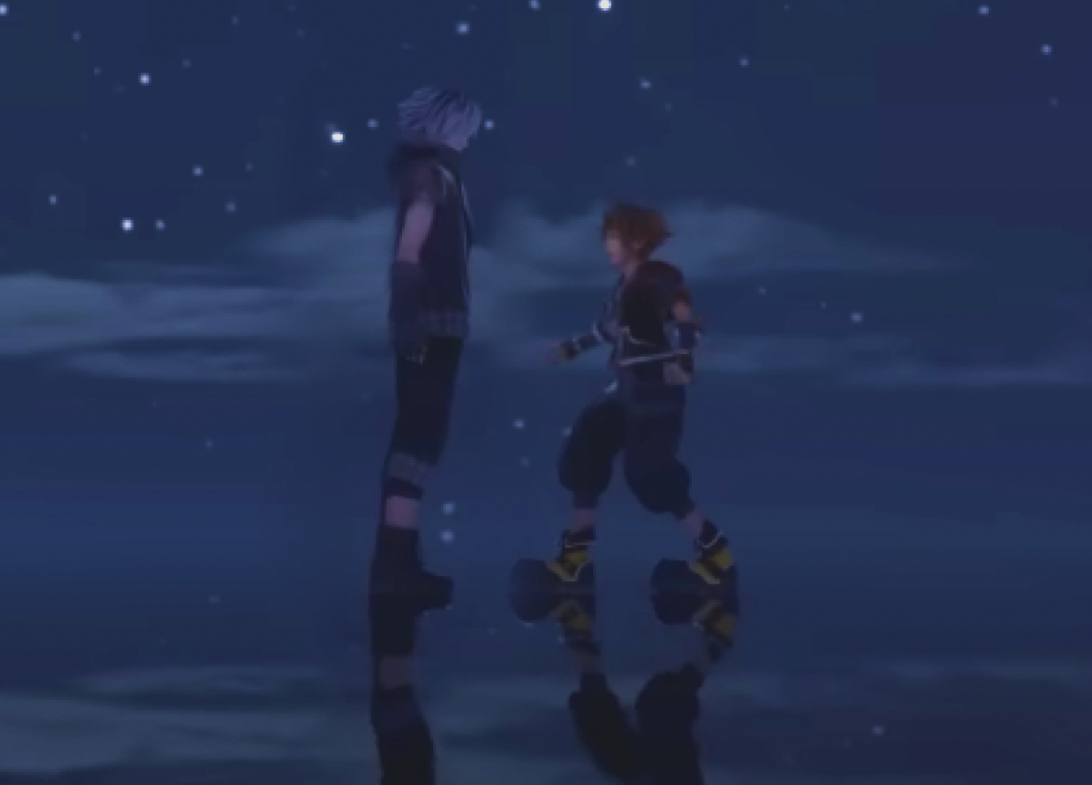
When Sora first arrives here, he encounters this new character and immediately recognizes him as Yozora. Sora knows due to his recent travels to ‘Toy Box’ where the video game Verum Rex resides, Rex’s extreme passion for the game, and Sora’s chat with the nameless star in the Final World before piecing himself back together to save his friends and go back in time.
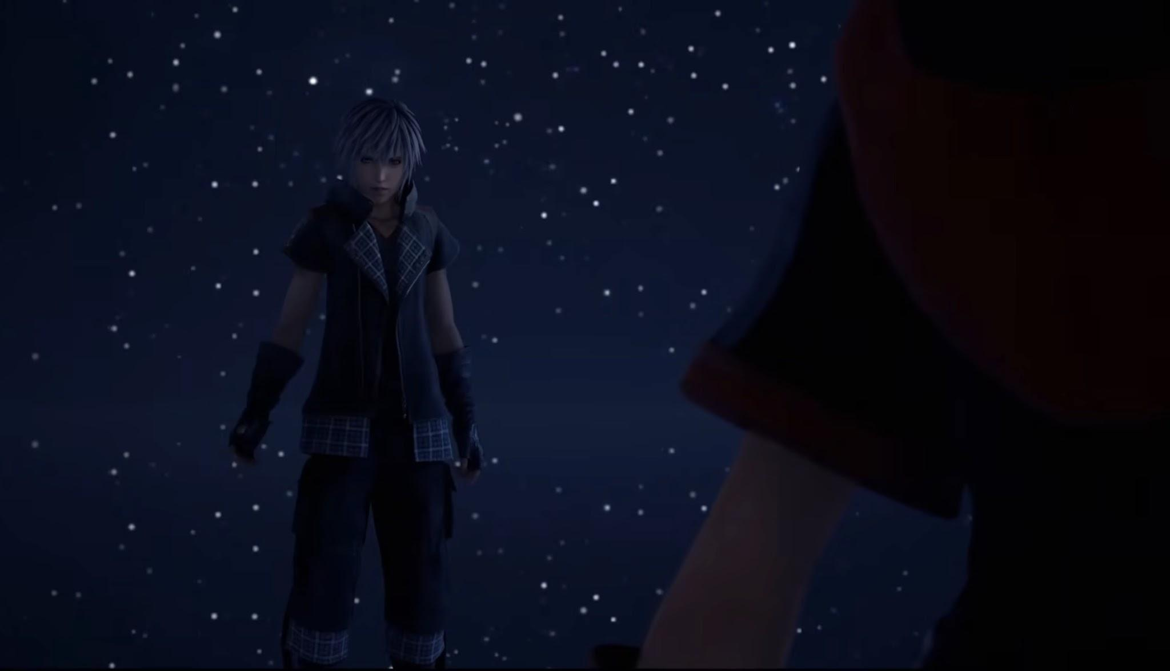
When Sora recognizes him, Yozora is visibly confused and says “You know me?”. Sora says, “Yeah, you’re Yozora right?”, and Yozora quickly asks for Sora to explain how he knows that. Then he asks Sora who he is. Sora tells Yozora his name and Yozora gets even more confused. Yozora explains to Sora that what he looks like right now, isn’t his true form or appearance. He is confused as to how Sora could recognize him as Yozora when his true form/identity has likely been stolen, destroyed, occupied, manipulated, or trapped. Yozora asks, “Why are you using Sora’s name?”, and Sora follows by saying, “Because… I am Sora”.
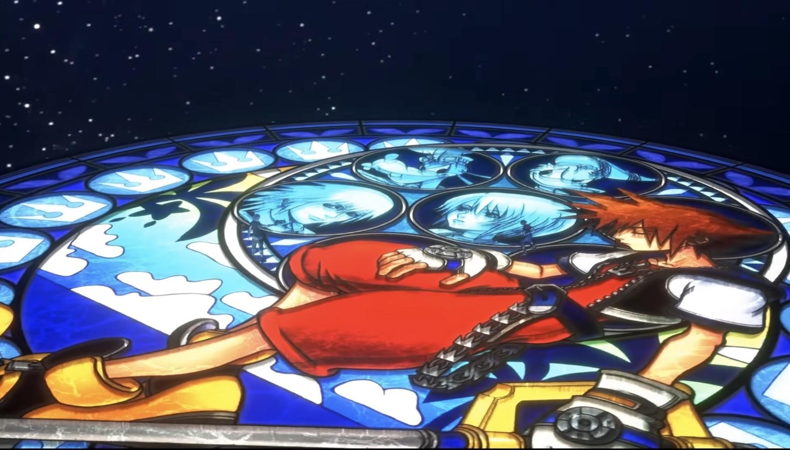
Yozora then tells Sora that if he truly is who he says he is, then his path is clear. He draws his weapon and aims it at Sora. Afterwards, the ground—or water—underneath them transforms into Sora’s “Dive Station”, giving the impression that Yozora has connected with Sora’s heart in some way, and this allows a bridge to form between their hearts. This is what pulls Sora into the World of Quadratum and out of the Final World.
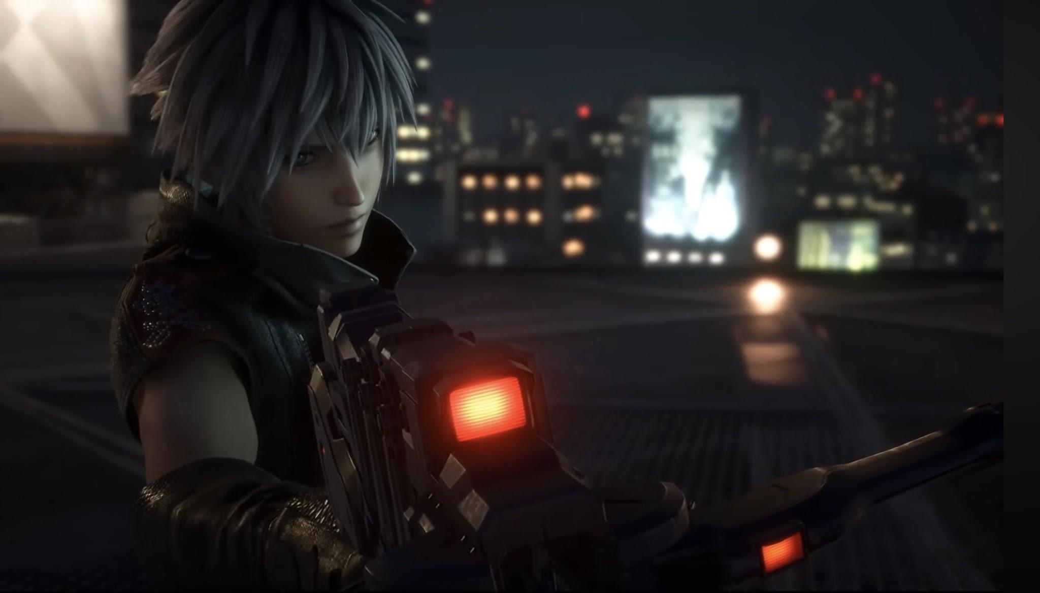
Following this sequence of events, Yozora states to Sora that he “accidentally” wandered into this place and went through some trials, then he was told to “save” Sora.
These directives to save are not a genuine act of “saving” someone. His directives were given to him specifically so that Sora’s drifting body (or vessel) is successfully imported into the world of Quadratum, utilizing Yozora (the main character from the Verum Rex Video Game that Rex is so passionate about) as a “Proxy-Vessel”.
In conclusion, the “Black Box”, and the masterful creation of “Proxy-Yozora”, the Master of Masters successfully creates a way to oversee, steward, and control both ends
of Sora’s existence, ultimately splitting his body, heart, and also his mind apart by different realities and circumstances.
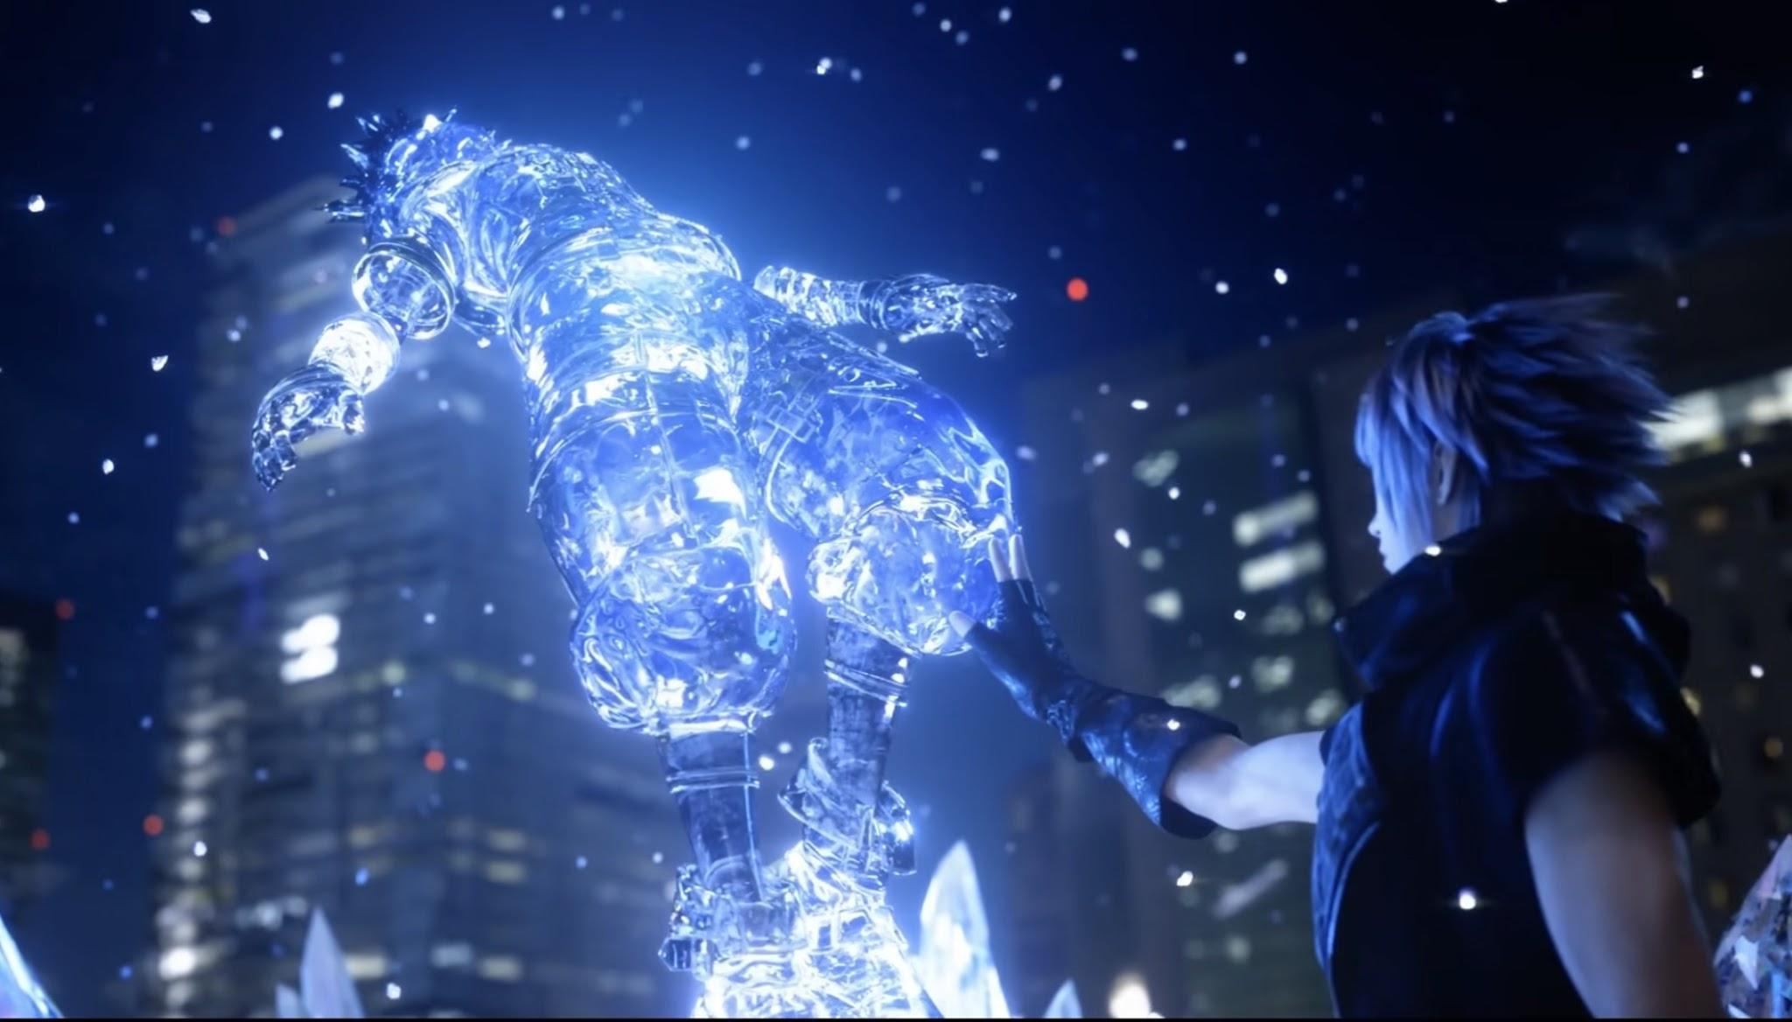
After Sora loses this battle between Yozora, he is crystallized and frozen by Yozora. He places a hand on Sora and says, “I will save you.” and a great flash of light fills the screen. According to established lore, Yozora did this to essentially “immobilize” Sora. This could mean a grand scale of things—but sticking to my theory—with the new trailer of Kingdom Hearts 4, it is entirely plausible that Yozora’s actions caused Sora’s memories to be scattered across the worlds within unreality (Coco, A Galaxy Far Far Away, Savana Central, Toy Box, etc).
